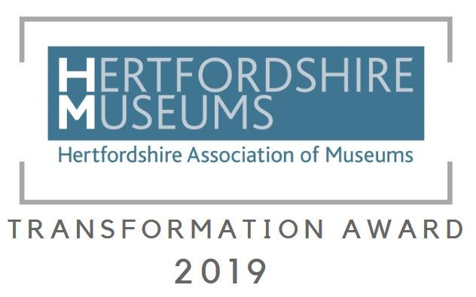

This award celebrates a new initiative, project or way of working that has transformed the way your museum works and has made a big difference.

The award will recognise the creative thinking that has resulted in your museum becoming more sustainable in the long term.

This activity must be a new area of improvement for your organisation, and have been introduced after 1st August 2018.

This category is open to all members of the Hertfordshire Association of Museums.

Application

Museum (complete below)
Contact name (name of contact person for the museum)
Contact’s position in the organisation (e.g. trustee / curator / steward / secretary etc.)
Contact phone number
Contact email address
Title of your project/initiative
When did the project/initiative start?
Description of your project
Please describe the project using questions below. Please remember to include relevant background information so short-listers can judge the impact of your project (question 3).

What did you do? (no more than 150 words)

- What was different about this way of working? (no more than 150 words)
- How has it made a difference? (no more than 150 words)
- How will it affect your future plans? (no more than 150 words)
Is your organisation volunteer run? If not, please answer additional question below. | Yes / No
Number of employed full time equivalent members of staff

Please complete and return your application to hertsmuseums@hertfordshire.gov.uk titled ‘ HAM Transformation Award’ no later than 15th September 2019

You will receive notification as receipt of application within 10 days – please contact us as soon as possible if you do not receive confirmation.

Prior to short-listing all applications will be kept in confidence and no details will be shared.

If you need further information or would like to discuss your application, please contact Gemma Papineau gemma.papineau@hertfordshire.gov.uk
Consent to use and retain personal information
Your personal information on this form will be retained so that you can be contacted for marketing and publicity purposes. By giving us information and completing this form you are agreeing to this.

Signature:………………………………………………………Date:………………

Print Name…………………………………………………………………………

Use of personal information
Hertfordshire Museums Development Service (Hertfordshire County Council) will collect and use the personal information that you give us to administer your entry for the Hertfordshire Association of Museums Object of the Year Award. This personal information may include name, physical address, email address, and phone number. Hertfordshire Museums Development Service (Hertfordshire County Council) is working with Hertfordshire Association of Museums to run the 2019 Museum Awards. Personal information collected will only be shared with third parties in order to provide the services that you have asked for, unless required by law. All data is stored in the UK. This data will be kept for 2 years.

Your Rights
Hertfordshire County Council will be the Data Controller for this information.
You have the following rights in relation to this data:
• You have the right to be informed about what information we hold about you and how we use it.
• You have the right to request copies of any information the Council holds about you by making a subject access request.
• If information we hold about you is factually inaccurate you have the right to have it corrected.
• You have the right to object to the way we are using your data.
• You have the right to request that your data is deleted. However we may be unable to delete your data if there is a need for us to keep it. In this case you will receive an explanation of why we need to keep the data.
• You can also request that we stop using your data while we consider a request to have it corrected or deleted. There may be some circumstances in which we are unable to do this however we will provide an explanation if this is the case.
• In certain circumstances you may also request data we hold about you in a format that allows it to be transferred to another organisation.
• In the event that decisions are taken using automated processes you have the right to request that these decisions are reviewed by a member of staff and to challenge these decisions.
If you would like to request copies of your data, request that your data is deleted or have any other queries in relation to data which the Council holds about you please contact the Data Protection Team.
Data Protection Team, Hertfordshire County Council, County Hall, Pegs Lane,Hertford SG13 8DQ Tel: 01992 588099. Email: data.protection@hertfordshire.co.uk
You can also contact our Data Protection Officer at dataprotection.officer@hertfordshire.gov.uk or in writing to the address above.
If you are unhappy with the way that Hertfordshire County Council has used your data or with the way we have responded to a request you also have the right to contact the Information Commissioner’s Office www.ico.org.uk .

Terms and conditions for Transformation Award entries
Copyright:- All images submitted must be free of copyright.
The winner will be decided by our panel of judges who have been selected following application and are external to Hertfordshire. Entries will be judged using a scoring matrix to ensure fairness.
The Museums Development Team may use photos and descriptions submitted for publicity and marketing purposes.
The Museums Development Team reserves the right to exclude any entry that is felt to be inappropriate.

