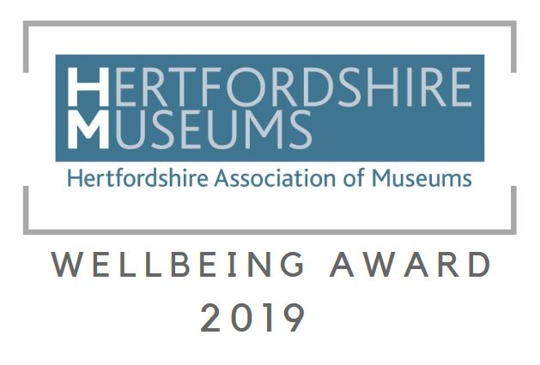

Have you made a significant change to your practice or developed a new project to reach out to new or existing audiences and improve mental wellbeing?

Are you regularly running sessions for people aimed at improving their quality of life? Then this award is for you!

Example projects might include an exhibition, partnership project, community work or a volunteering initiative. Anything that helps people connect with one another, be active, learn something new or be mindful.

This award recognises the significant efforts that our museums have put into increasing the wellbeing of Hertfordshire’s communities.

The activity could be a new or existing area of work for your organisation and must have been running for at least some of 2019.

This category is open to all members of the Hertfordshire Association of Museums.

Application
Museum (complete below)
Contact name (name of contact person for the museum)
Contact’s position in the organisation (e.g. trustee / curator / steward / secretary etc.)
Contact phone number
Contact email address
Social Media details
Title of your accessibility project/initiative
When did the project start?
Description of your project/initiative
Please describe the project/initiative using questions 1-4. Please remember to include relevant background information so short-listers can judge the impact of your project.

- What did you do? (no more than 150 words)

- Who was the target audience for this project? (no more than 150 words)

- Why was this project important for your organisation? (no more than 150 words)

- How did this project make a difference? (no more than 150 words)

Is your organisation volunteer run? If not, please answer additional question below. | Yes / No
Number of employed full time equivalent members of staff
Photography permission for those present at event for publicity and marketing purposes | Yes/No

Please complete and return your application to hertsmuseums@hertfordshire.gov.uk titled ‘ HAM Accessibility Award’ no later than 15th September 2019.

You will receive notification as receipt of application within 10 days – please contact us as soon as possible if you do not receive confirmation.

Prior to short-listing all applications will be kept in confidence and no details will be shared.

If you need further information or would like to discuss your application, please contact Gemma Papineau gemma.papineau@hertfordshire.gov.uk

Consent to use and retain personal information
Your personal information on this form will be retained so that you can be contacted for marketing and publicity purposes. By giving us information and completing this form you are agreeing to this.

Signature:………………………………………………………Date:………………

Print Name…………………………………………………………………………

Use of personal information
Hertfordshire Museums Development Service (Hertfordshire County Council) will collect and use the personal information that you give us to administer your entry for the Hertfordshire Association of Museums Accessibility Award. This personal information may include name, physical address, email address, and phone number. Hertfordshire Museums Development Service (Hertfordshire County Council) is working with Hertfordshire Association of Museums to run the 2019 Museum Awards. Personal information collected will only be shared with third parties in order to provide the services that you have asked for, unless required by law. All data is stored in the UK. This data will be kept for 2 years.

Your Rights
Hertfordshire County Council will be the Data Controller for this information.
You have the following rights in relation to this data:
• You have the right to be informed about what information we hold about you and how we use it.
• You have the right to request copies of any information the Council holds about you by making a subject access request.
• If information we hold about you is factually inaccurate you have the right to have it corrected.
• You have the right to object to the way we are using your data.
• You have the right to request that your data is deleted. However we may be unable to delete your data if there is a need for us to keep it. In this case you will receive an explanation of why we need to keep the data.
• You can also request that we stop using your data while we consider a request to have it corrected or deleted. There may be some circumstances in which we are unable to do this however we will provide an explanation if this is the case.
• In certain circumstances you may also request data we hold about you in a format that allows it to be transferred to another organisation.
• In the event that decisions are taken using automated processes you have the right to request that these decisions are reviewed by a member of staff and to challenge these decisions.
If you would like to request copies of your data, request that your data is deleted or have any other queries in relation to data which the Council holds about you please contact the Data Protection Team.
Data Protection Team, Hertfordshire County Council, County Hall, Pegs Lane,Hertford SG13 8DQ Tel: 01992 588099. Email: data.protection@hertfordshire.co.uk
You can also contact our Data Protection Officer at dataprotection.officer@hertfordshire.gov.uk or in writing to the address above.
If you are unhappy with the way that Hertfordshire County Council has used your data or with the way we have responded to a request you also have the right to contact the Information Commissioner’s Office www.ico.org.uk .

Terms and conditions for Accessibility Award entries
Copyright:- All images submitted must be free of copyright.
The winner will be decided by our panel of judges who have been selected following application and are external to Hertfordshire. Entries will be judged using a scoring matrix to ensure fairness.
The Museums Development Team may use photos and descriptions submitted for publicity and marketing purposes.
The Museums Development Team reserves the right to exclude any entry that is felt to be inappropriate.

